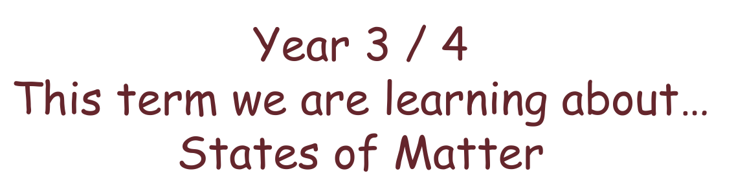
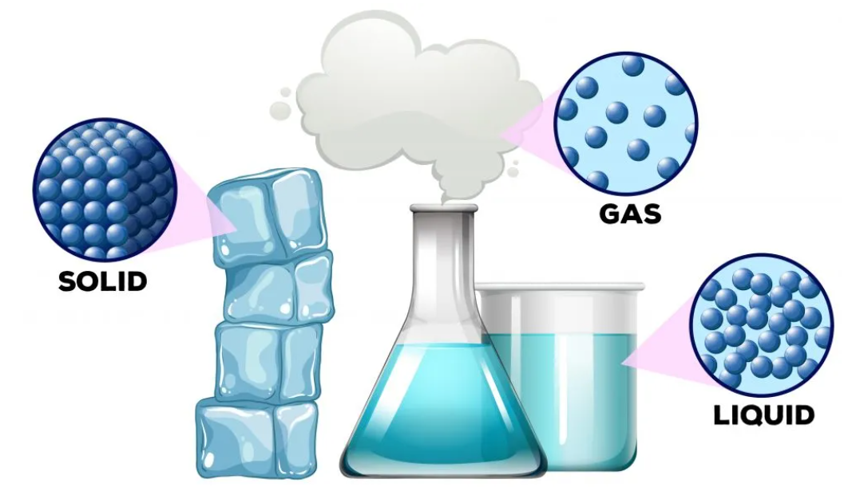

Texts we are reading this term are..
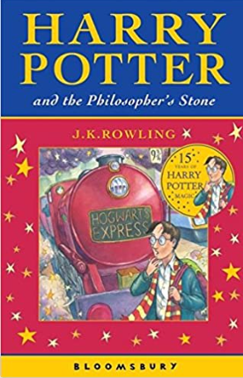
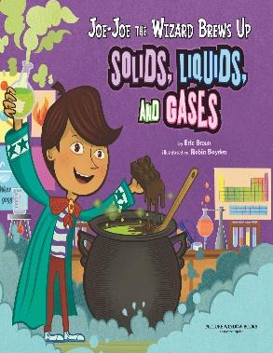
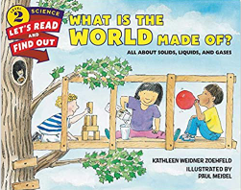
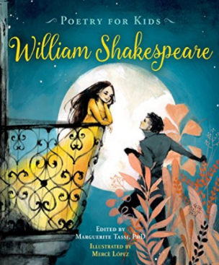
Other texts to enjoy...
Curious Pearl explains States of Matter by Eric Braun
Mrs Wrinkle and the Emotion Potion by Angela King
The Wizards of Once by Cressida Cowell

https://www.amazon.co.uk/Harry-Potter-Philosophers-Stone-Rowling/dp/0747532745
https://www.amazon.com/Joe-Joe-Wizard-Solids-Liquids-Science/dp/1404872388

https://literarycurriculum.co.uk/literary-leaves/poetry-for-kids-william-shakespeare-illustrated-edition/
https://www.amazon.co.uk/What-World-Made-Lets-Read-Find-Out/dp/0062381954

